Lab 7: Password Security and Hashing Analysis

Objective
Upon completion of this laboratory exercise, students should be able to:
1. Understand the importance of strong passwords.
2. Analyze password complexity and strength.
3. Generate cryptographic hash values using SHA-256.
4. Observe how small changes in input affect hash outputs.
5. Explain the avalanche effect in cryptographic hash functions.
6. Appreciate the role of hashing in password storage and authentication systems.

Introduction
Passwords are the first line of defence against threats to digital systems and user accounts. Weak passwords can be easily guessed or cracked using brute-force and dictionary attacks.
Modern systems do not store passwords in plain text. Instead, passwords are converted into fixed-length values known as hashes using cryptographic hash functions such as SHA-256.
The avalanche effect means that a small change in the input produces a significantly different hash value.

Software and Tools Required
• Notepad
• Internet Browser
• Online SHA-256 Generator
• HashCalc

Part A: Password Creation and Strength Analysis
Step A1: Create five passwords of varying complexity (Very Weak, Weak, Medium, Strong, Very Strong).
Password Type | Example
Very Weak | abc123
Weak | password2025
Medium | Ahmad2025
Strong | Ahmad@2025
Very Strong | A#hM9@2x!L7$

Table 1: Password Complexity Analysis
Password | Length | Uppercase | Lowercase | Number | Special Character | Strength Rating
irf154 | 6 | none | yes | yes | none | Very Weak
password2026 | 12 | none | yes | yes | none | Weak
Irfan2026 | 9 | Yes | yes | yes | none | Medium
Irfan@2026 | 10 | yes | yes | yes | yes | Strong
I#nM5@2j!L7$ | 12 | yes | yes | yes | yes | Very Strong

Step A2: Evaluate password strength using an online password strength checker.
Evidence Required:
Screenshot A1 – Show at least one weak password and one strong password evaluation.
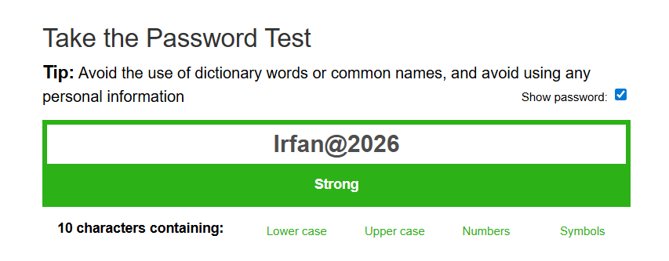
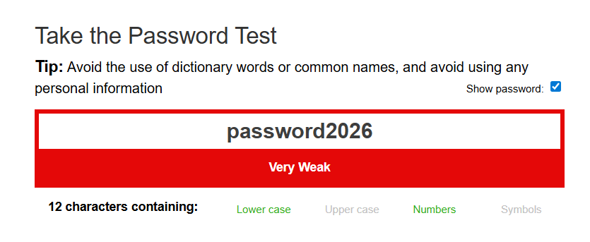

Part B: SHA-256 Hash Generation
Generate SHA-256 hashes for all five passwords.
*alternatively, you can use command prompt and type this command:
certutil -hashfile filename.txt SHA256
-You have to create files containing each of the passwords.
Table 2: SHA-256 Hash Results
Password | SHA-256 Hash Value
Password 1 | 69b3627799062823b7c53f16d196e6b5f724c5e56a6f7e748ec244e8f2bace4c
Password 2 | d50b5d2e0121b6bf12211074470ec0f796becd7351ba34ab0c939c06e7185eb4
Password 3 | 2e9f1c6a6c18ddec69523b4fa1034c47827af65830d5c799f098a78bbc5e92c1
Password 4 | 21f33947723fe5fa593228e0729ad6f108cedfff663bb87b7abf9288f23928fe
Password 5 | 00a00334c370b4e00256135abc31dd13c27337007e4afeb4d7c26435a5a1da58

Evidence Required:
Screenshot B1 – Hash generation for Password 1.
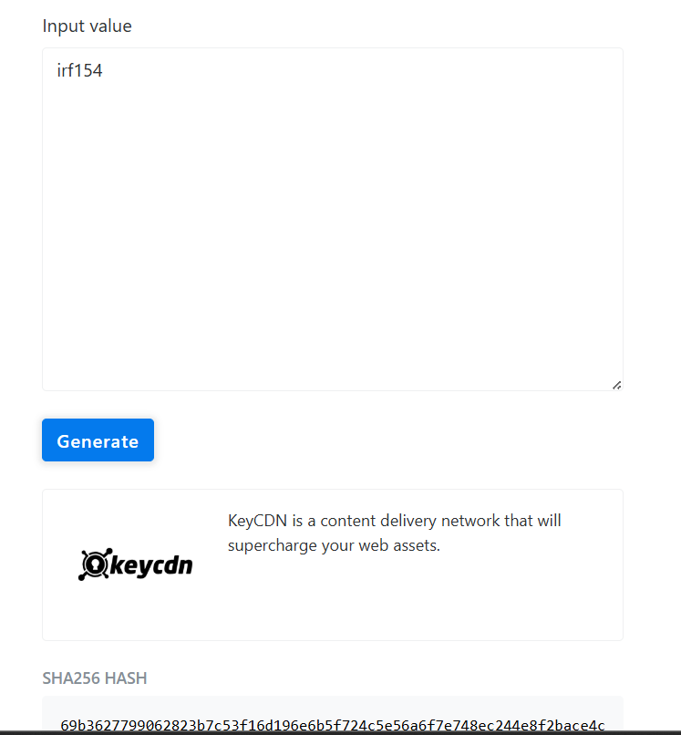
Screenshot B2 – Hash generation for Password 5.
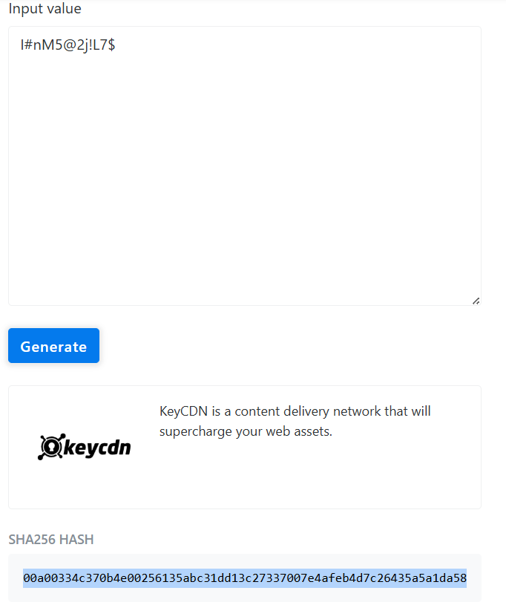

Part C: Avalanche Effect Demonstration
Modify one character in a selected password.
Example:
Original Password: Ahmad@2025
Modified Password: Ahmad@2026
Generate SHA-256 hashes for both and compare the outputs.

Table 3: Avalanche Effect Observation
Item | Password | SHA-256 Hash
Original | Ahmad@2025 | 8e659621fd62577a79ebbd1702dde26c0bad46c6707b36481a53568e92912997
Modified | Ahmad@2026 | 5fde15904a1db242062ce1e06d0a22c38e59a217eb0479b9b7e9f3c8ab231a78
Evidence Required:
Screenshot C1 – Original password and hash.
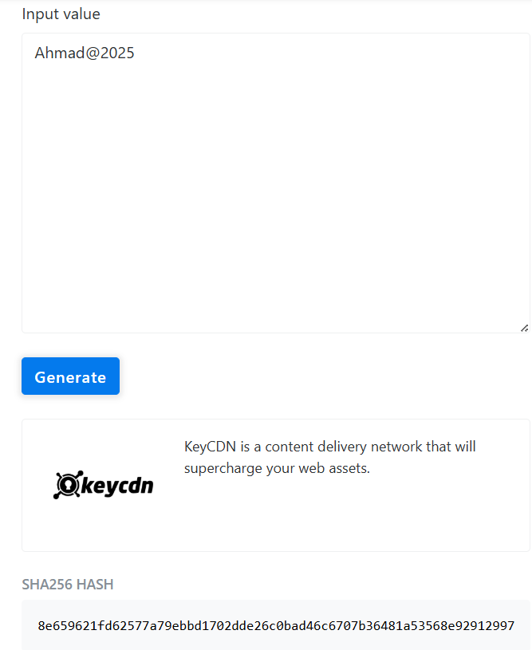
Screenshot C2 – Modified password and hash.
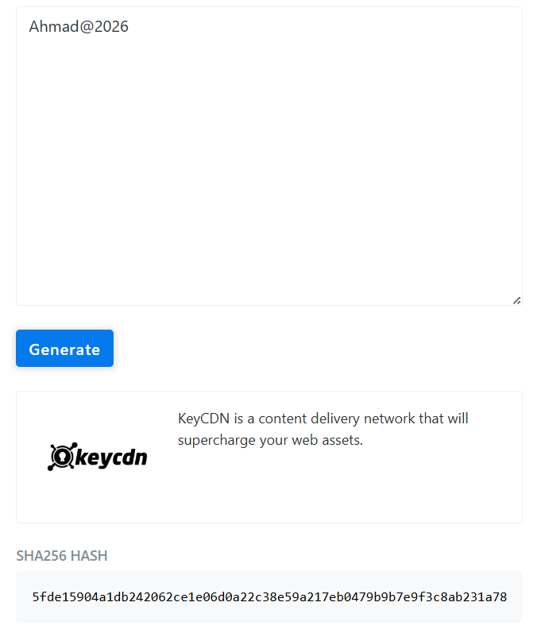

Part D: Hash Generation Using HashCalc
Open HashCalc, select SHA-256, and generate a hash for one password.
Evidence Required:
Screenshot D1 – HashCalc interface showing the generated SHA-256 hash.

Discussion Questions
Q1. Why are strong passwords more secure than weak passwords?
Q2. What characteristics make a password difficult to crack?
Q3. What is a cryptographic hash function?
Q4. Why do modern systems store password hashes instead of plain-text passwords?
Q5. What happened to the SHA-256 hash when only one character was changed?
Q6. Explain the avalanche effect based on your results.
Q7. Can the original password be recovered directly from a SHA-256 hash? Justify.
Q8. List three real-world applications of cryptographic hashing.
Q9. What are the advantages of SHA-256 compared to MD5?
Q10. If an attacker obtains password hashes, what additional techniques can better protect passwords?

